Quel temps fait-il ?
Listen carefully to my weather report, put a tick in the right box.

 |  |  | 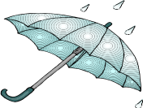 | 
1.
2.
3.
4.
5.
6.
7.

Quel temps fait-il ?
Listen carefully to my weather report, put a tick in the right box.

1.
2.
3.
4.
5.
6.
7.

